P PEV seies Piezoelectric Gas Flow Valve

Features:
• Stainless steel construction
• 0 to 525 sccm
• Precise linear control flow rate
• Suitable for all dry non-corrosive gases
compatible with materials

Description:
The Piezoelectric Gas Flow Valve Model PEV-1 is a high precision gas leak valve which uses a piezoelectric bender element that responds directly to a voltage signal, which causes the opening and closing of the valve.The piezoelectric bender element responds within milliseconds to a voltage signal of 0 to 100-Volt DC. All PEV-1 valves have a two micron filter on the inlet, viton1 seals and a coaxial BNC connector(Kings KC-79-117).The threshold voltage of the valve is 20 to 30 volts, maximum voltage is 100 Volt DC and inlet pressure shouldnot exceed 50 PSI.
The PEV-1 Series valves are designed to be fail-safe. In the event of a power loss, the PEV-1 will close and remain closed until power is restored to valve. All valves manufactured by KEY HIGH VACUUM PRODUCTS,INC. are leak tested on a helium mass spectrometer at 3 x 10-9 torr with a one-atmosphere differential on the inlet and exhibit no leakage.

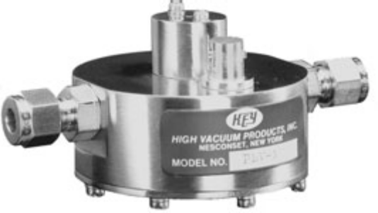
PEV-1 Ordering Information
Part Number Description Price
PEV-1 Piezoelectric Valve 1/4" Swagelok1 Fittings
PEV-1-VCR1 Piezoelectric Valve 1/4" Male VCR's1
PEV-1-001 Replacement Viton1 Seals
PEV-1-002 Inlet Filter 2 Micron
PEV-1-003 RG-188 Cable 10 Foot With One Mating Connector Only
PEV-1-004 1/4" FNPT Inlet Fitting & 1" OD Tube Outlet Fitting

